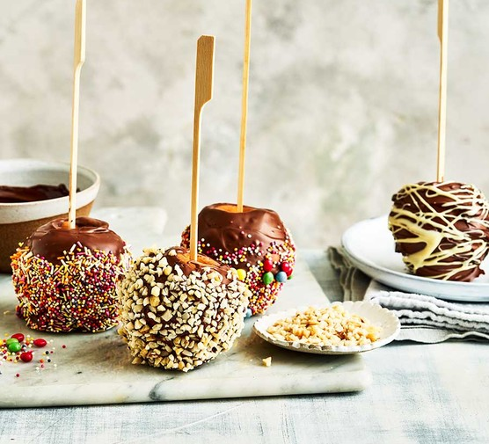
Chocolate Apples

INGREDIENTS
200g milk chocolate, finely chopped
4 small eating apples
To decorate
Sugar strands, finely chopped nuts, sprinkles, honeycomb pieces
50g of each white and dark chocolate, chopped (optional)
You will also need
4 skewers, wooden chopsticks or large lolly sticks
METHOD
STEP 1
Put the chocolate in a heatproof bowl set over a pan of just simmering water, being careful that the bowl doesn’t touch the water. Stir frequently for 10 mins until completely melted, smooth and shiny. Remove from the heat. Alternatively, heat the chocolate in short bursts in the microwave, stirring between each burst, until melted.
STEP 2
Put the apples in a heatproof bowl and pour over boiling water from the kettle. Drain carefully, and wash under hot water to remove any residual wax on the skin. This helps the chocolate stick better. Pat dry with kitchen paper, remove the stalks and push a lolly stick or skewer in its place.
STEP 3
Line a baking tray or large board with baking parchment. Hold the apples by their sticks and dunk into the melted chocolate. Use a spoon to coat the tops of the apples if you like. Once the apples are completely coated, hold over the bowl for a few seconds for excess chocolate to drip back into it, then place, stick pointing up, onto the prepared tray. Leave to set for a minute or two.
STEP 4
Tip the decorations into separate bowls. When the chocolate on the apples is just starting to set but not fully firm, sprinkle the decorations onto the apples. Hold them on their side and rotate using the stick to completely cover. Place back on the tray and leave until completely set.
STEP 5
If using the white and dark chocolate to decorate, heat each separately, as you did the milk chocolate in step 1, then leave to cool slightly. Melt the dark chocolate first, then when the chocolate apples are set hard, use a teaspoon to drizzle this over them, again holding the stick so the apple is on its side and rotating the apple. Have a sheet of baking parchment underneath to catch any drips. Place back on the tray and leave to set, then repeat the process using the white chocolate. Will keep in an airtight container in a cool place for two days.

