Lets Cook...
Green Deli Salad

Prep Time:  20 Minutes | Cook Time:  15 Minutes | Serves:  4
Things you need: Equipment:
Camembert Cheese  1  Lettuce  1  Cucumber  1/2  Celery  2 Sticks  Cabbage  3 Leafs  Cured Meat  1 Pack  Toppings:  Crisps  Cheese  Fruit  Ham |  | Knife  Scissors (Optional)  Small Baking Dish  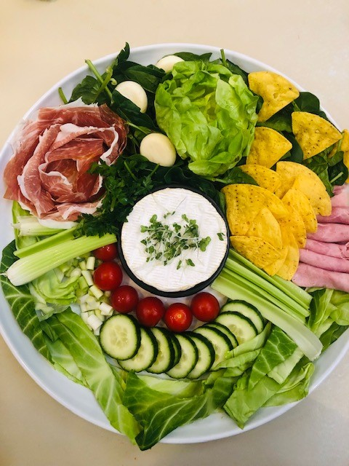
Here’s How:

1 | Rinse and chop all the salad you can find!  Sometimes clean scissors help speed this up! | 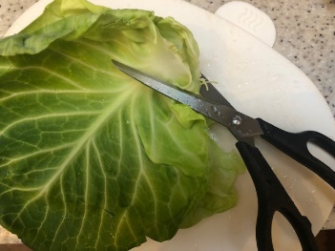
2 | Cook Camembert cheese in oven for 15-20 minutes at 220 degrees. Gently push a spoon on white top of cheese… if it feels floppy, it’s ready. When cooled a bit, move cheese to salad plate. | 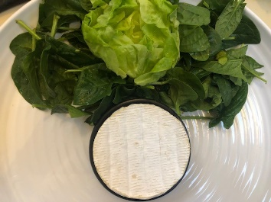
3 | Add more salad, make it green! Have fun, notice shapes and patterns, make faces or  rainbows! | 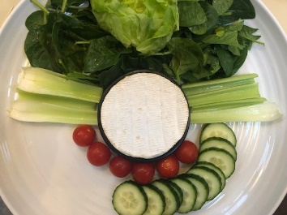
4 | Add cured meats too… can you make a rose shape? Do this by overlapping cured meat all way round a cup. Round and round until used all meat and can’t see cup edge anymore. | 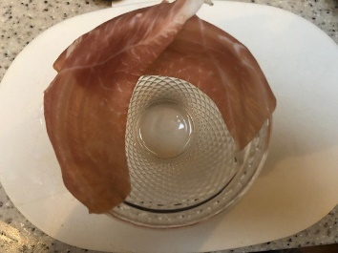
5 | Turn cup upside down on salad plate. Gentle wiggle and lift cup off. Fill your plate adding fruit, cheese, crisps and rolled ham. | 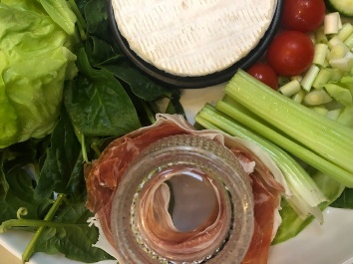 | 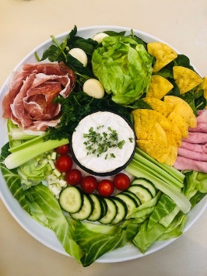
6 | Cut white top off cheese and throw away. All done! You can now dip your crunchy salad into your sticky cheese, enjoy!

