Lets Cook...
Green Smoothie

Prep Time:  10 Minutes | Cook Time:  None | Serves:  1
Things you need: Equipment:
Spinach  1 Bowl Fulll  Banana  1  Grapes  1/2 Mug  Blueberries  1/4 Mug  Apple  1 |  | Blender  Knife  Chopping Board  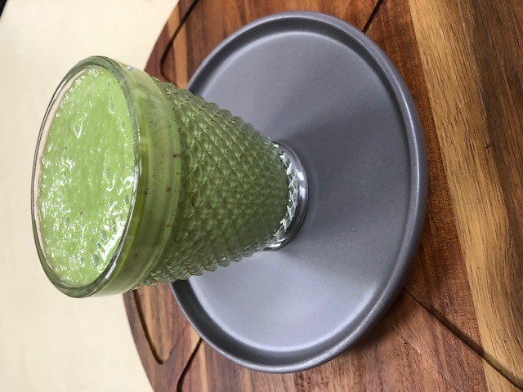
Here’s How:

1 | Rinse fruit with water. | 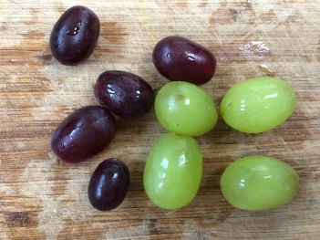
2 | Chop fruit, when chopping apple, throw apple core away or plant it! | 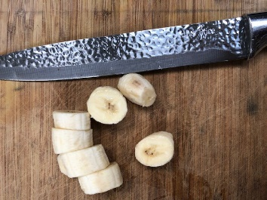
3 | Rinse bowl full of spinach | 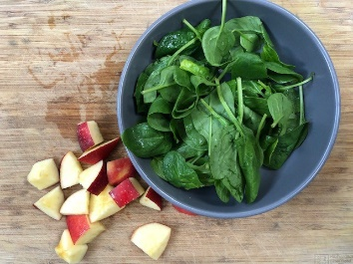
4 | Pour half a mug of yoghurt. | 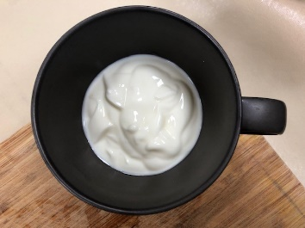 | 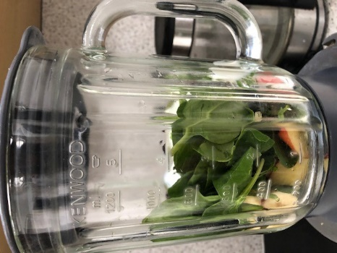
5 | Add all to blender and blitz as smooth as you can.
6 | Pour into glass and enjoy! |  | 