Lets Cook...
Mint Tea

Prep Time:  5 Minutes | Cook Time:  5 Minutes | Serves:  1
Things you need: Equipment:
Fresh Mint Leaves  3 Leaves  Dried Mint  1/2 tablespoon  Boiling Water  1 Mug |  | Kettle  Tea Cup  Tea Strainer  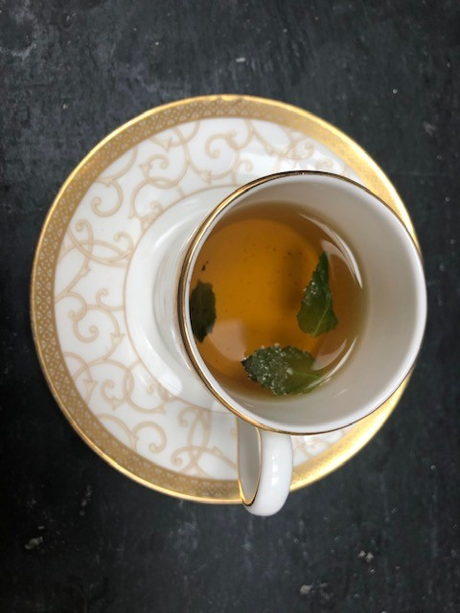

Here’s How:

1 | Boil kettle and get mug out ready. | 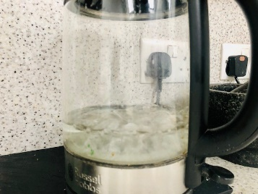
2 | Fill a tea strainer with dried mint. |  | 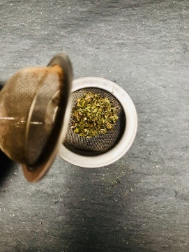
3 | Pour boiling water in mug, gently place tightly closed tea strainer in water. |  | 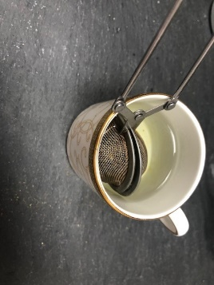
4 | Rub the leaves, smell them, can you smell mint? Pull 3 leaves off stem, wash them. |  | 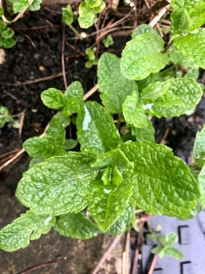  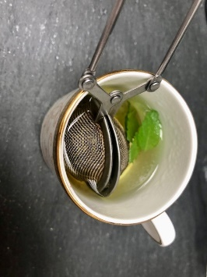
5 | Drop leaves in mug and leave it a short while.
6 | Remove strainer and mint leaves, add a drop of cool water and enjoy! |  | 