Lets Cook...
Shortbread

Prep Time:  25 Minutes | Cook Time:  25 Minutes | Serves:  6-8
Things you need: Equipment:
Caster Sugar  1/4 Mug  Rice Flour  1/4 Mug  Plain Flour  1 Mug  Butter  1/2 Mug  Flavourings:  Caster Sugar |  | Flan Tin  Blender  Spoon  Knife  Chopping Board  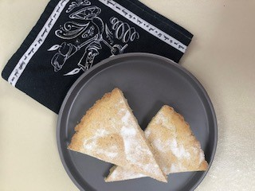

Here’s How:

1 | Grease Tin with butter, rub all around. |  | 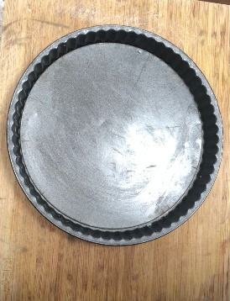  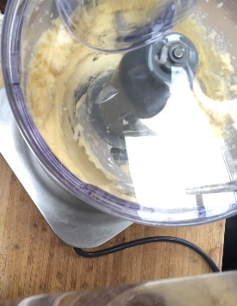
2 | Blitz butter and sugar in blender until creamy.
3 | Add 2 tablespoons of the flour, blitz, then add rest of flour and blend in blender until nearly a dough ball, pop in tin. |  | 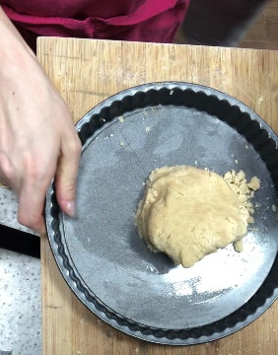
4 | Squash, push and roll dough flat to cover tin. |  | 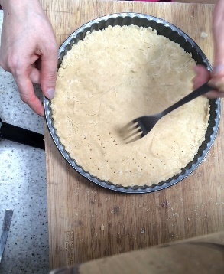  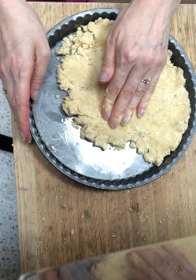
5 | Prick with fork. Bake at 160 degrees for 25 minutes or until done
6 | Sprinkle with sugar whilst warm. Cool 10 minutes, slice. Enjoy!

