Lets Cook...
Pluto Platter

Prep Time:  10 Minutes | Cook Time:  N/A | Serves:  1
Things you need: Equipment:
Oranges  2 Small  Cherries  3  Banana  1  BlueBerries  2  Ham  1 Slice |  | Chopping Board  Knife  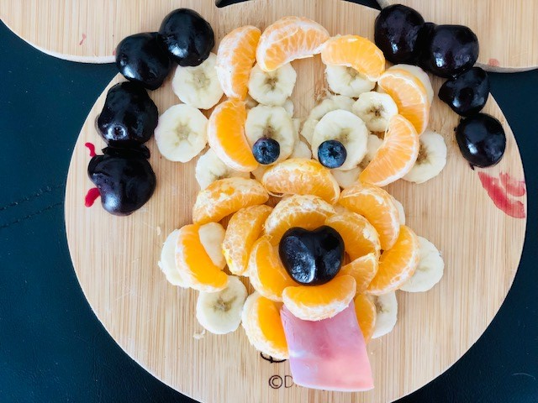

Here’s How:

1 | Shall we make Pluto? Peel banana. Chop into thin slices. | 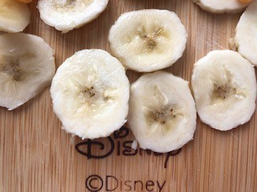
2 | Peel oranges into segments. Lay on chopping board to make head shape. | 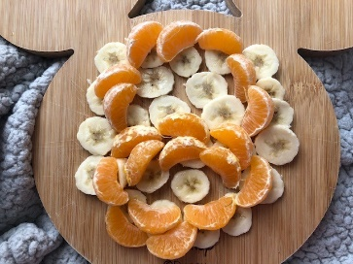  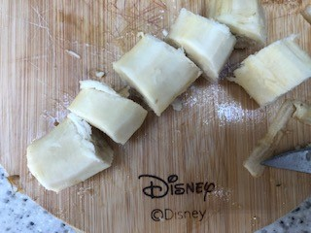
3 | Add blueberries as eyes.
4 | Cut cherries and remove pip. Arrange as ears and nose. | 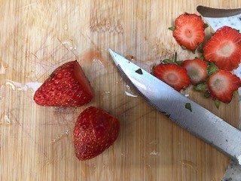
5 | Roll ham and tuck into mouth as a tongue. | 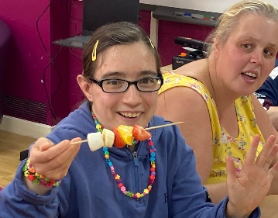
6 | Can you see Pluto? Enjoy! |  | 