Lets Cook...
Plum Cake

Prep Time:  10 Minutes | Cook Time:  45 Minutes | Serves:  8
Things you need: Equipment:
Plums  9  Honey  4-5 Tablespoons  Plain Flour  200 grams  Butter  200 grams  Caster Sugar  100 grams  Vanilla  2 teaspoons  Salt  1 pinch  Baking Powder  1 teaspoon |  | Bowl  Cake Tin  Knife  Chopping Board  Mixer  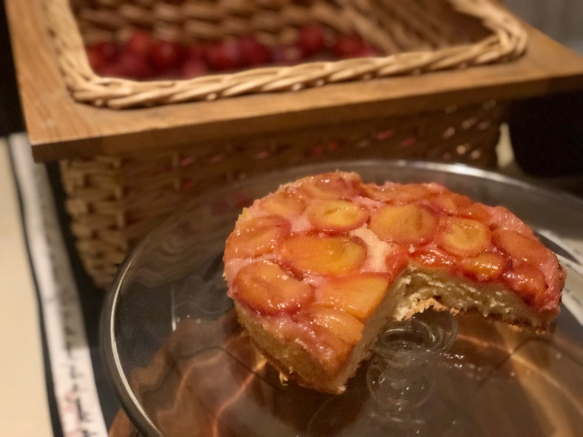  Sieve

Here’s How:

1 | Wash plums, cut in half, throw away seeds. | 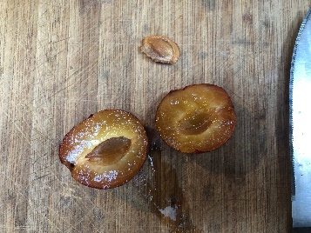
2 | Rub tin with some butter. Lay plums halves in bottom, cover in honey. | 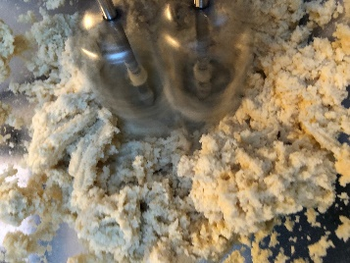  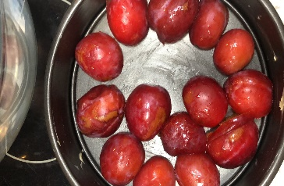
3 | In bowl, use hand mixer to blend butter, sugar, baking powder and sieved flour until mixed and white.
4 | Add egg and salt then blend again until mixed, spread on top of plums. |  | 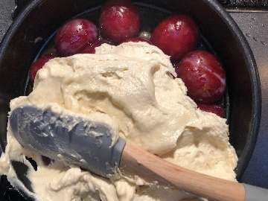
5 | Sprinkle with ground almonds and bake around 190 degrees for 35 minutes and if needed 10 more minutes at 170 degrees. |  | 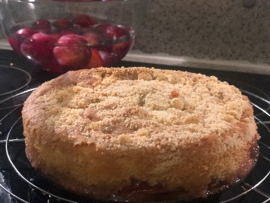
6 | Check cooked through with a skewer and cool a while in tin. Flip cake over and enjoy! Great with cream |  | 