Lets Cook...
Chocolate Coins

Prep Time:  1-2 Hours | Cook Time:  3 Minutes | Serves:  2
Things you need: Equipment:
Cooking chocolate  Half a big bar |  | Pan  Bowl  Chocolate Coin Mould  Spatula  Freezer  Hobs  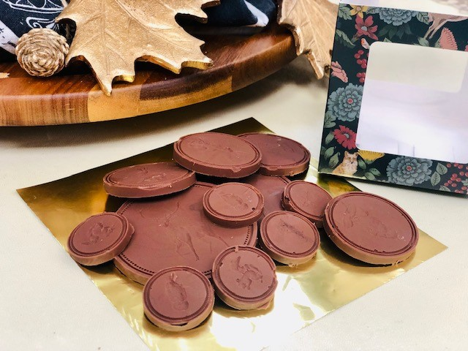

Here’s How:

1 | Break chocolate into bowl, put it on top of pan of 1 inch water. | 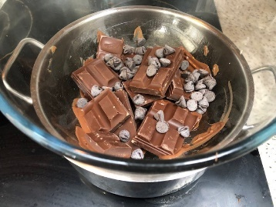  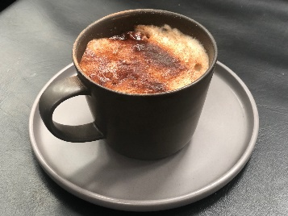
2 | Cook on medium heat, stir until melts. | 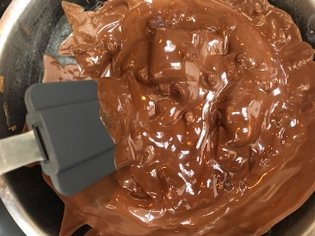
3 | Carefully lift bowl off with oven gloves ready to pour in mould. | 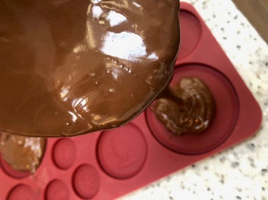
4 | Keep moving bowl and pouring until all full. |  | 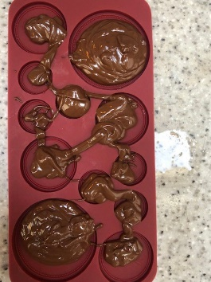
5 | Spread flat with spatula then freeze for 1 or 2 hours. |  | 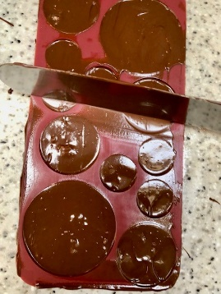
6 | Using your hands, pop out from underneath! Give as a gift or eat them all up! Enjoy! | 