Lets Cook...
Karls BLT
Video on our website! Go to Past Online Activities!

Prep Time:  15 Minutes | Cook Time:  5 Minutes | Serves:  1
Things you need: Equipment:
Bacon  3 pieces  Lettuce  1 Handful  Tomato  ½  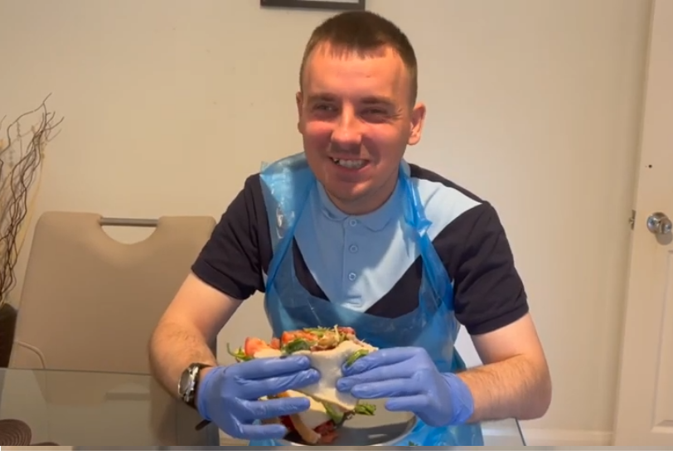  Butter  Small bit  Mayonnaise or Ketchup  1 Squirt |  | Frying Pan  Sharp Knife  Chopping board  Butter Knife  Tongs  Hobs

Here’s How:

1 | Cook bacon in frying pan until crispy. | 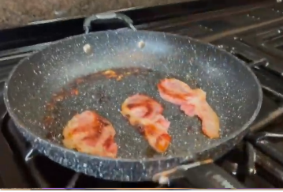  
2 | Butter bread. |  | 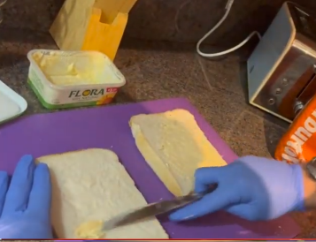
3 | Carefully chop tomato slices. | 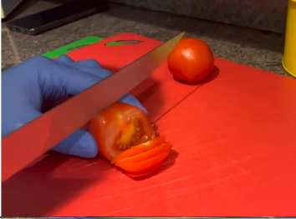
4 | Add salad, tomatoes and cooked bacon to the sandwich. |  | 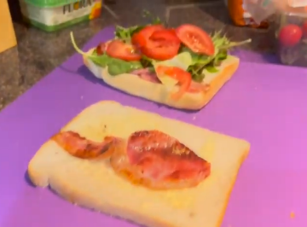
5 | Add sauce and put sandwich together, then carefully slice. |  | 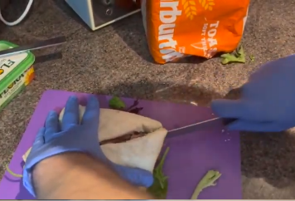
6 | Enjoy! | 