Lets Cook...
Enchiladas

Prep Time:  20 Minutes | Cook Time:  50 Minutes | Serves:  10
Things you need: Equipment:
Olive Oil  3 tablespoons  Rep Peppers  2 (Deseeded, chopped)  Red Chillies  3 (Sliced)  Red Onions  2 (Sliced)  Garlic  2 cloves (crushed)  Ground Coriander  1 tablespoon  Chicken Breasts  6 cut into small chunks  Tortillas  10  200g Cheddar Cheese  Grated  Refried Beans  1 tin  Passatta  1 700ml bottle |  | Large pan  Frying pan  Wooden spoon  Oven proof dish  Chopping Board  Sharp knife  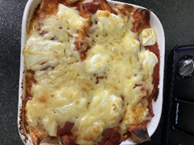
Here’s How:

1 | Heat 2 tablespoons of oil in a big pan. Fry the onions, peppers, chilli and garlic for 10 mins.  Stir in the ground coriander.  Get another pan. Heat 1 tablespoon of oil. Fry the chicken until it is golden. | 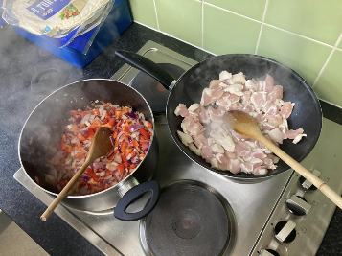
2 | Stir in the beans and sweetcorn (optional). Then add 150ml passata. Stir together. |  | 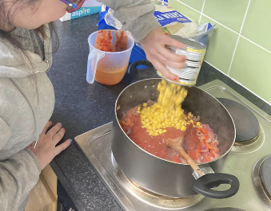
3 | Lay the tortillas in an oven proof dish. Put some of the mixture in the tortilla. Fold the ends of the tortillas over and roll it up. Pour some passata sauce over the top. Top with cheese. |  | 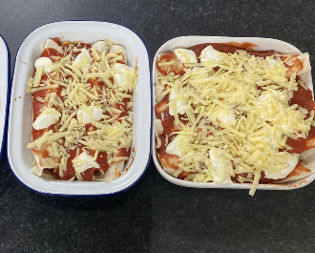
4 | Heat the oven to 200c/180c fan/ gas 6 and bake for 30 mins.  Enjoy! | 