Lets Cook...
Beef Tacos

Prep Time:  15 Minutes | Cook Time:  60 Minutes | Serves:  6
Things you need: Equipment:
Onion  1  Rep Pepper  1  Olive Oil  1 tablespoon  Paprika  1 pinch  Garlic  2 cloves (crushed)  Minced Beef  500g  Beef Stock  250ml  Taco shells  12  Tomatoes  2  Spring Onion  1  Coriander  3 sprigs |  | Sharp knife  Chopping board  Large pan  Baking tray  Spoon  Oven  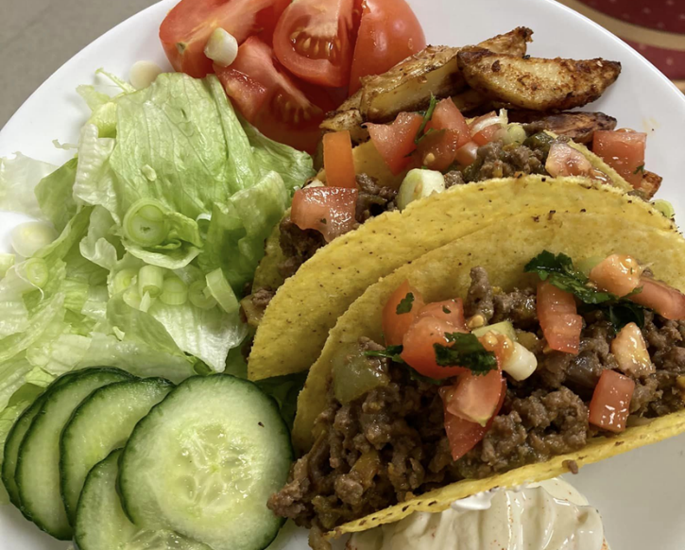
Here’s How:

1 | Peel and dice the onions and peppers. Peel and slice the garlic. Heat 1 tablespoon of oil in a large pan on low heat. Add the vegetables. Add 1 pinch of paprika for 2 minutes. |  | 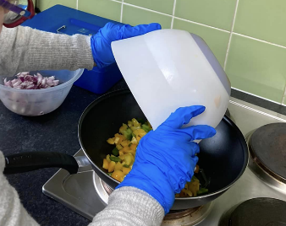
2 | Add the minced beef until it has browned. Pour in the stock. Cook for 45 minutes.  Preheat oven to 180c/350f/gas 4 | 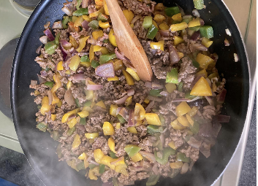
3 | To make the salsa, chop the tomatoes. Slice the spring onions. Chop the coriander leaves. If you would like to, add lime juice to taste. Mix. |  | 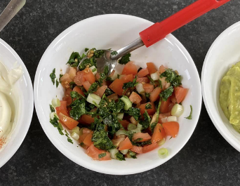
4 | Spread the taco shells out on a baking tray. Put in the oven for 3 minutes until crisp.  Then fill the shells with the meat and salsa. Serve with guacamole and enjoy! |  | 