Lets Cook...
Butter Chicken Curry
Prep Time:  15 Minutes | Cook Time:  60 Minutes | Serves:  6
Things you need: Equipment:
Chicken Breast  500g  Tomato Puree  2 tablespoons  Easy Garlic  1 tablespoon  Onions  3  Garam Masala  2 teaspoons  Corriander  Handful  Butter  100g  Single Cream  100ml  Natural Yoghurt  100g  Ginger  Thumb sized piece  Ground turmeric and Ground Cumin  1 teaspoon |  | Sharp knife  Chopping board  Large pan  Baking tray  Spoon  Oven  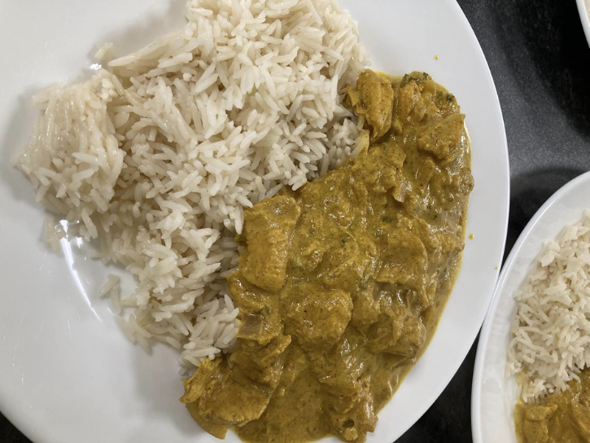
Here’s How:
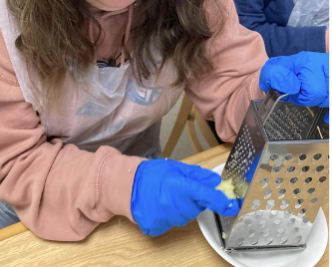

1 | Peel and grate the ginger. Chop the onions and set aside. Chop coriander. | 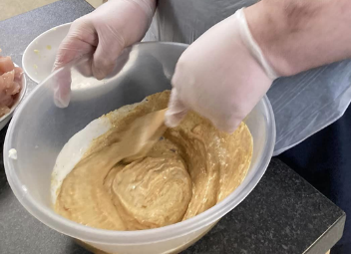
2 | Put the yoghurt, tomato puree, garlic, turmeric, cumin, garam masala and grated ginger in a bowl and mix. |  | 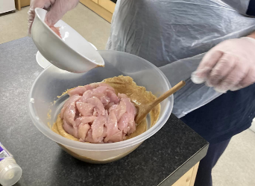
3 | Cut the chicken breast into bite size pieces and cover them in the yoghurt mixture. This is called marinating. Add the coriander. |  | 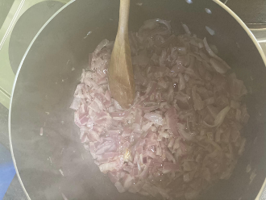
4  5  6  7 | Melt the butter in a saucepan on low heat and add the onions. Fry for 5-7 minutes  Turn up the heat and add the chicken. Let this sizzle for 10 minutes. Stir often.  Add 100ml of water and put a lid on the pan. Leave simmering for 20 mins. Then add the cream, stir and simmer for another 20 mins.  Serve with naan bread and rice.  Enjoy! |  | 