Lets Cook...
Naburn’s Chicken Tikka Masala

Prep Time:  15 Minutes | Cook Time:  30 Minutes | Serves:  6
Things you need: Equipment:
Boneless Chicken Thighs  800g  Minced Garlic  3 tablespoons  Garam Masala  4 teaspoons  Tumeric Powder  1 teaspoons  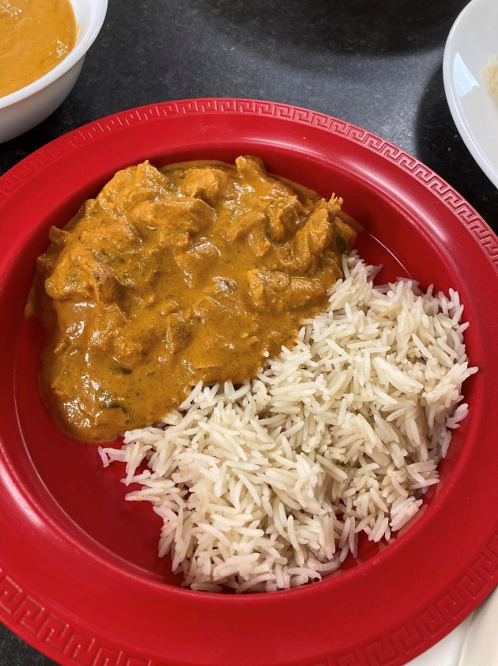  Cumin Powder  2 teaspoons  Chilli Powder  2 tea spoons  Passata  400g  Plain Yoghurt  1 Cup  Heavy Cream  1 ¼ cups  Onion  1 large- chopped  Vegetable Oil  2 Tablespoons |  | Chopping Board  Sharp Knife  Pan  Large Bowl
Here’s How:

1 | In a bowl, mix together all of these ingredients:  Diced Chicken  Yoghurt  2 Tablespoons minced Garlic  2 teaspoons garam masala  1 teaspoon turmeric  1 teaspoon ground cumin  1 teaspoon chilli powder.  Coat the chicken with the mix and set aside for 15 minutes. | 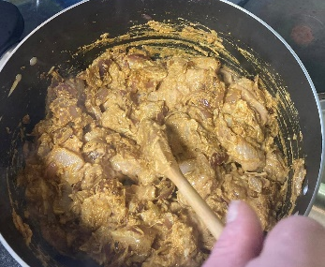  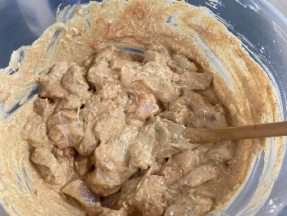
2 | Heat 1 tablespoon oil in the pan. Add the chicken and fry for 3 minutes on each side. Set aside and keep warm. |  | 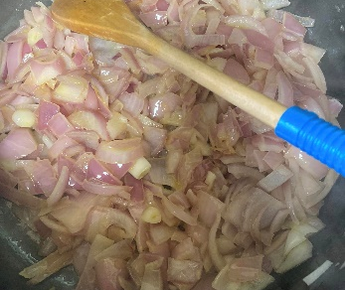
3 | Heat another 1 tablespoon oil in the pain. Fry your chopped onions until soft.
4 | Add 2 tablespoons garlic,1 teaspoon garam masala, 1 teaspoon cumin and 1 teaspoon turmeric. Fry for 1 minute.
5 | Pour in the passata and 1 teaspoon chilli powder. Let simmer for 15 minutes, stirring every few minutes. |  | 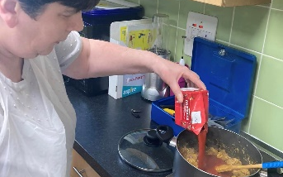

6  7 | Stir the cream through the sauce. Add the chicken back into the pan and cook for 10 minutes until the chicken is cooked through, and the sauce is bubbling.  Enjoy with rice and naan bread! |  | 