Lets Cook...
Caramel Apple Tarts
Prep Time:  5 Minutes | Cook Time:  20 Minutes | Serves:  4
Things you need: Equipment:
Packed Pie Crust  1 pack  Apples  3  Butter  Half a stick  Sugar  1 cup  All Purpose Flour  2 cups  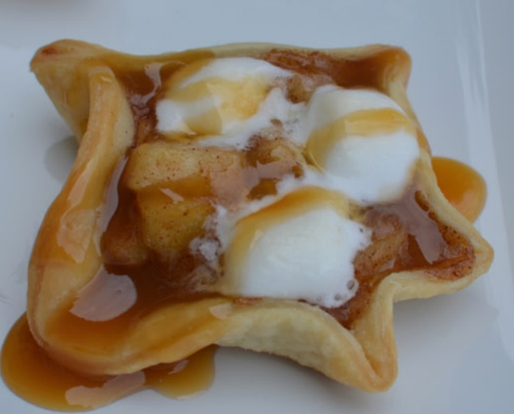  Cinnamon Powder  1 teaspoon  Cup of Mini Marshmallows  ¾ Cup  Caramel Syrup  3 tablespoon |  | Chopping Board  Sharp Knife  Peeler  Mixing Bowl  Large Spoon  Deep Pan
Here’s How:

1 | Peel the apples and cut them into small pieces. Put them into a mixing bowl. | 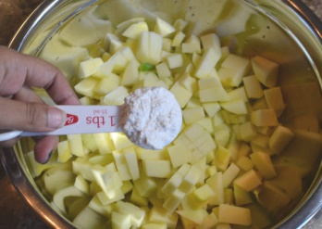  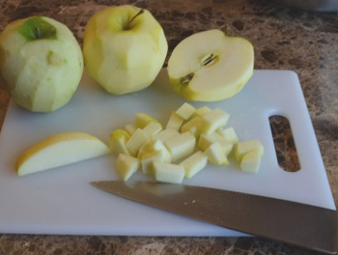
2 | Add 2 tablespoons of flour. | 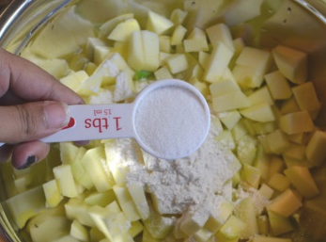  S
3 | Add 3 tablespoons of the sugar. |  | 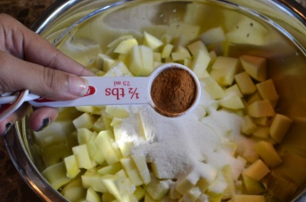
4 | Add the Cinnamon Powder |  | 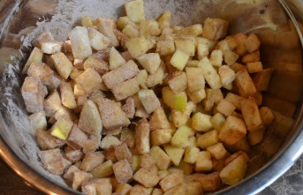
5 | Mix everything together |  | 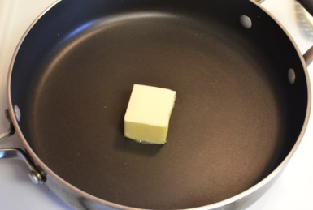
6  7  8  9  10  11  12  13  14 | Melt the butter in a pan  Put the apples in the pan and cook on medium-high heat for 10 minutes.  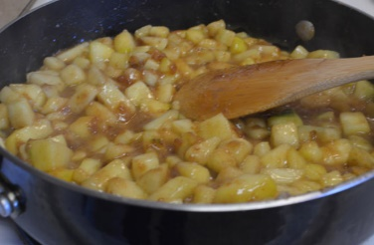  Add 1 cup of water and the rest of the sugar. When it starts bubbling, turn off the heat and leave to cool.  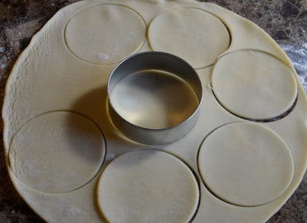  Roll out the pie crust and cut into small round circles.  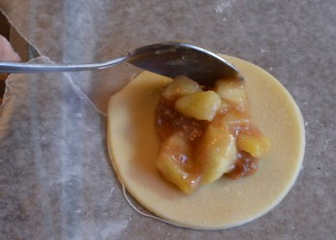  Spoon the apple pilling into the middle of each pastry  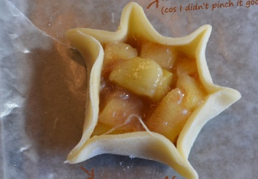  Pinch the sides of the pastry up.  (Pinch hard so they don’t leak!)  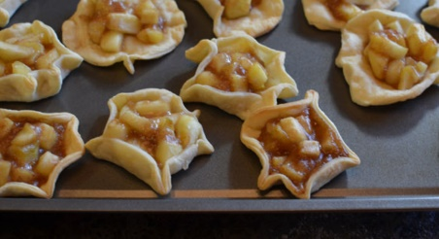  Put into the oven at ___ for 10 minutes.    Put some mini marshmallows in each tart. Put back in the oven for 3 minutes.  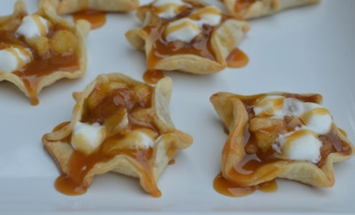  Take out of the oven and let them cool. Drizzle with caramel syrup and enjoy! | 