Lets Cook...
Ricotta Filled Scones (Sochniki)

Prep Time:  35  Minutes | Cook Time:  30 Minutes | Serves:  9 Scones
Things you need: Equipment:
Butter  5 Tablespoons  Sugar  ¾ Cup and 2 tablespoons  Sour Cream  4 Tablespoons  Baking Powder  1 teaspoon  Ricotta Cheese  16 Ounces  All Purpose Flour  2 ½ Cups  Semolina  4 Tablespoons  Vanilla Extract  ½ Teaspoon  Egg  1 Separated  Whole Milk  1 cup |  | Mixing Bowl x2  Spatula  Knife  Spoon  Baking Tray  Baking Paper  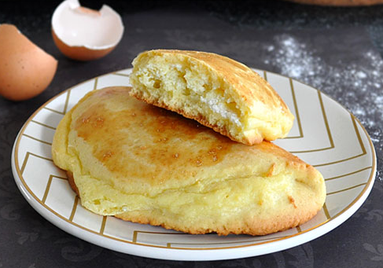
Here’s How:

1 | In a mixing bowl, stir together softened butter and sugar. |  | 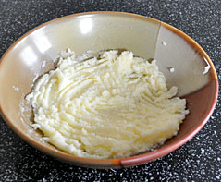
2 | Add sour cream and eggs. Mix well. |  | 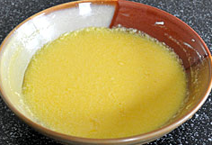
3  4  5  6  7  8  9 | Combine flour and baking powder. Add to the mixture gradually. Keep mixing with a spoon or with your hands. When the dough is soft and smooth form into a log shape.  To prepare the filling, in a separate mixing bowl, mix ricotta, sugar, semolina, vanilla extract and egg yolk. Mix well.  Divide the log into 9 equal portions.  Using your hands, press each potion of dough into a 5 inch circle.  Heat the oven to 190 degrees c. Cover a baking tray with baking paper. Placing the circles onto the tra, add 1 ½ tablespoons of filling onto one half of each circle.  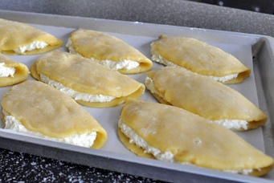  Lift the other half of the circle to cover the filling. Press the edges down lightly.    Bakie in the preheated oven for 25-30 minutes, until golden brown. Enjoy! |  | 